**Acceleration**

Acceleration tells how much an object’s speed changes in one second.

When an object speeds up, its acceleration is in the direction of motion.

When an object slows down, its acceleration is opposite the direction of motion.

Objects in free fall gain or lose 10 m/s of speed every second

**Algebraic kinematics –** You must follow these steps to solve an algebraic kinematics calculation.

1. Define a positive direction, i.e. the direction “away from the detector. Label that direction.
2. Indicate in words what portion of motion your are considering, e.g. “motion from launch to the peak of the flight.”
3. Fill out a chart, *including signs and units*, of the five kinematics variables:

*v*o [initial velocity]

*v*f [final velocity]

Δ*x* [displacement]

*a*  [acceleration]

*t* [time for the motion to happen]

1. If three of the five variables are known, the problem is solvable; use the kinematics equations to solve.

*v*f = *v*o + *at*

Δ*x* = *v*o*t* + ½*at*2

*v*f2 = *v*o2 + 2*a*Δ*x*

A fourth equation may occasionally be useful:

Δ*x* = ½*t*(*vo* + *v*f)

**Angular Momentum**

Before calculating angular momentum, it is necessary to define a rotational axis.

The angular momentum *L* of an object is given by:

*Iω* for an extended object

*mvr* for a point object, where *r* is the “distance of closest approach”

The “direction” of angular momentum is given by the right-hand rule.

**Conservation of angular momentum:**

When no torques act external to a system, angular momentum of the system cannot change.

Angular momentum is a vector – angular momentums in the same sense add, angular momentums in opposite senses subtract.

Angular momentum is conserved *separately* from linear momentum. Do not combine them in a single equation.

**Impulse**

The impulse-momentum theorem can be written for angular momentum, too.

*τ*Δ*t* = Δ*L*

A change in angular momentum equals the net torque multiplied by the time the torque is applied.

**Kinematic Definitions**

Displacement indicates how far an object ends up from its initial position, regardless of its total distance traveled.

Average velocity is displacement divided by the time interval over which that displacement occurred.

Instantaneous velocity is how fast an object is moving at a specific moment in time.

**Position-time graphs**

To determine how far from the detector an object is located, look at the vertical axis of the position-time graph.

To determine how fast an object is moving, look at the steepness (i.e. the slope) of the position-time graph.

To determine which way the object is moving, look at which way the position-time graph is sloped.

A position-time slope like a front slash / means the object is moving away from the detector.

A position-time slope like a back slash \ means the object is moving toward the detector.

**Velocity-time graphs**

To determine how fast an object is moving, look at the vertical axis of the velocity-time graph.

To determine which way the object is moving, look at whether the velocity-time graph is above or below the horizontal axis.

An object is moving away from the detector if the velocity-time graph is above the horizontal axis.

An object is moving toward the detector if the velocity-time graph is below the horizontal axis.

To determine how far an object travels, determine the area between the velocity-time graph and the horizontal axis.

On a velocity-time graph it is not possible to determine how far from the detector the object is located.

Most everyday motion can be represented with straight segments on a velocity-time graph.

**Projectile motion**

When an object is in free-fall,

* its VERTICAL acceleration is always 10 m/s per second.
* its HORIZONTAL acceleration is always zero.

Velocities in perpendicular directions add just like perpendicular forces.

The magnitude of an object’s velocity is known as its speed.

To approach a projectile problem, make two kinematics charts: one vertical, one horizontal.

**Rotational kinematics -- Definitions**

Angular displacement *θ* indicates the angle through which an object has rotated. It is measured in radians.

Average angular velocity *ω* is angular displacement divided by the time interval over which that angular displacement occurred. It is measured in rad/s.

Instantaneous angular velocity is how fast an object is rotating at a specific moment in time.

Angular Acceleration *α* tells how much an object’s angular speed changes in one second. It is measured in rad/s per second.

Angular acceleration and centripetal acceleration are independent. Angular acceleration changes an object’s rotational speed, while centripetal acceleration changes an object’s direction of motion.

**Relationship between angular and linear motion**

The linear displacement of a rotating object is given by *rθ*, where *r* is the distance from the rotational axis.

The linear speed of a rotating object is given by *v = rω*

The linear acceleration of a rotating object is given by *a* = *rα*.

**Torque**

The torque provided by a force is given by *τ = Fd*⊥, where *d*⊥ refers to the “lever arm.” (see pp. 126-127 of the 5-steps book for a more detailed summary of lever arm.)

**Rotational Inertia**

Rotational inertia *I* represents an object’s resistance to angular acceleration.

For a point particle, rotational inertia is *MR*2, where *M* is the particle’s mass, and *R* is the distance from the axis of rotation.

For a complicated object, its rotational inertia may be given by an equation relating its mass and radius. The chart on the next page from Giordano’s text should not be memorized, but used as a guide. These equations will be given as needed.

Rotational inertia of multiple objects add together algebraically.

**Newton’s Second Law for Rotation**

An angular acceleration is caused by a net torque: *α* = 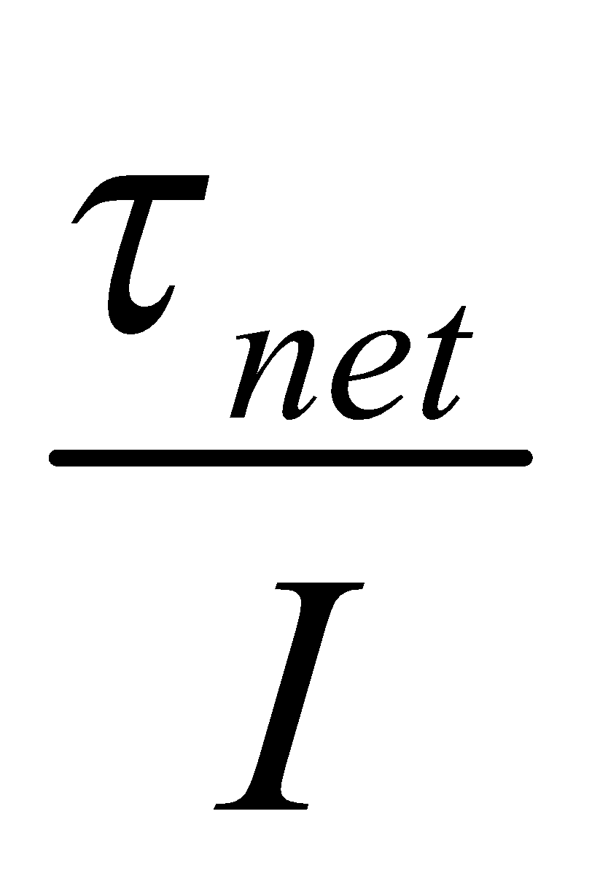

**Simple harmonic motion**

Many objects that vibrate back-and-forth exhibit simple harmonic motion. The pendulum and the mass-on-a-spring are the most common examples of simple harmonic motion.

An object in simple harmonic motion makes a position-time graph in the shape of a sine function.

An object in simple harmonic motion experiences a net force whose

* magnitude increases a linear function of distance from the equilibrium position
* direction always points toward the equilibrium position

Definitions involving simple harmonic motion:

* Amplitude (*A*): The maximum distance from the equilibrium position reached by an object in simple harmonic motion
* Period (*T*): The time for an object to complete one entire vibration.
* Frequency (*f*): How many entire vibrations an object makes each second.

The period of a mass on a spring is given by the equation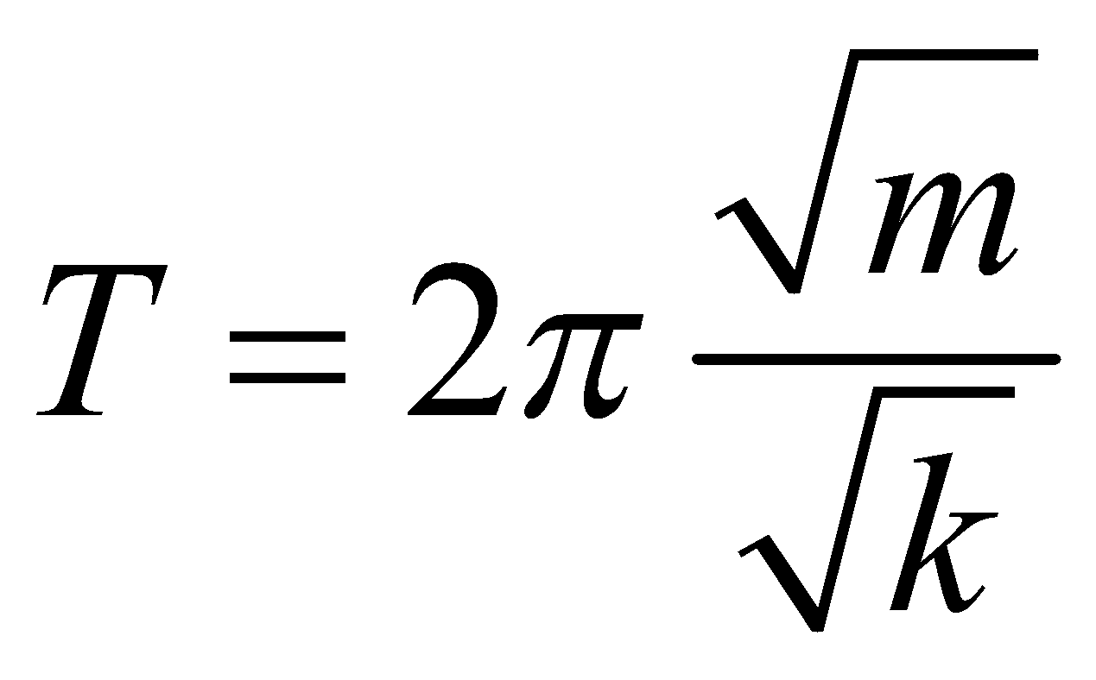. The mass attached to the spring is *m*; the spring constant of the spring is *k*.

The period of a pendulum is given by the equation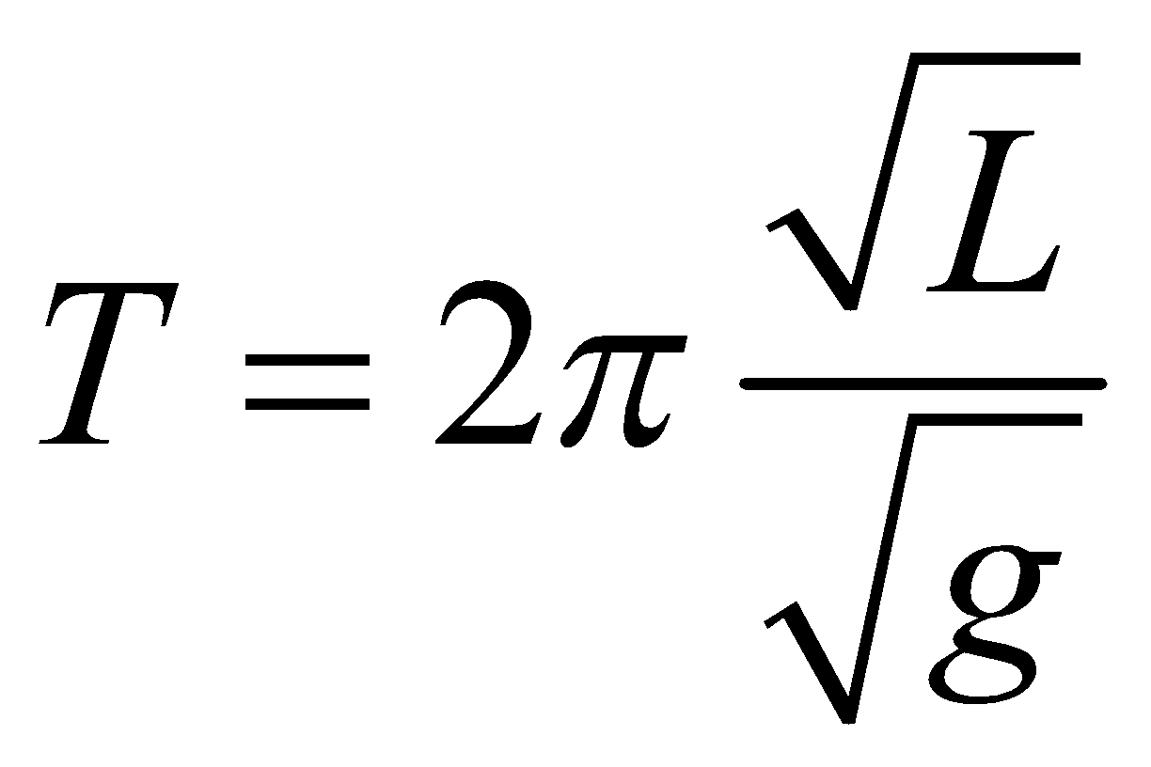. The length of the pendulum is *L*; the gravitational field is *g*.

**What is conserved?**

Mechanical energy is conserved when there is no net work done by external forces. (And when there’s no internal energy conversion.)

Angular momentum is conserved when no net external torque acts.

Momentum in a direction is conserved when no net external force acts in that direction.

**Momentum**

Momentum is equal to mass times velocity: *p = mv*

The standard units of momentum are newton∙seconds, abbreviated N∙s.

The direction of an object’s momentum is always the same as its direction of motion.

**Impulse:**

Impulse, *J*, can be calculated in either of two ways:

1. Impulse is equal to the change in an object’s momentum
2. Impulse is equal to the force experienced multiplied by the time interval of collision, *J = Ft*

Impulse has the same units as momentum, N∙s.

Impulse is the area under a force vs. time graph.

**Conservation of momentum in collisions**

When no external forces act on a system of objects, the system’s momentum can not change.

The total momentum of two objects before a collision is equal to the objects’ total momentum after the collision.

Momentum is a vector: that is, total momentum of two objects moving in the same direction adds together; total momentum of two objects moving in opposite directions subtracts.

A system’s center of mass obeys Newton’s second law: that is, the velocity of the center of mass only changes when an external net force acts on the system.

**Wave definitions**

*Crests:* the high points on a wave

*Troughs:* the low points on a wave

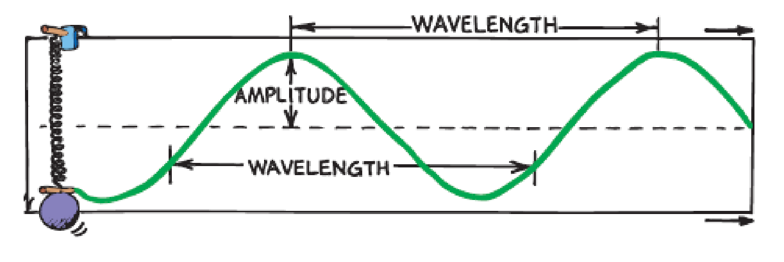

*Amplitude (A):* the distance from the midpoint to the crest or trough

*Wavelength (λ):* the distance between identical parts of the wave.

*Frequency (f):*the number of waves to pass a position in one second.

*Period (T):* the time for one wavelength to pass a position

The unit of frequency is called the hertz (Hz).

Whenever a wave changes materials, the wave’s frequency remains the same.

The speed of a wave depends on the material through which the wave moves.

It is the disturbance that moves along the string [or any material], not parts of the string itself.

The energy carried by a wave depends on the wave’s amplitude.

**Equations relating frequency, period, wavelength, wave speed**

Frequency and period are inverses of each other: 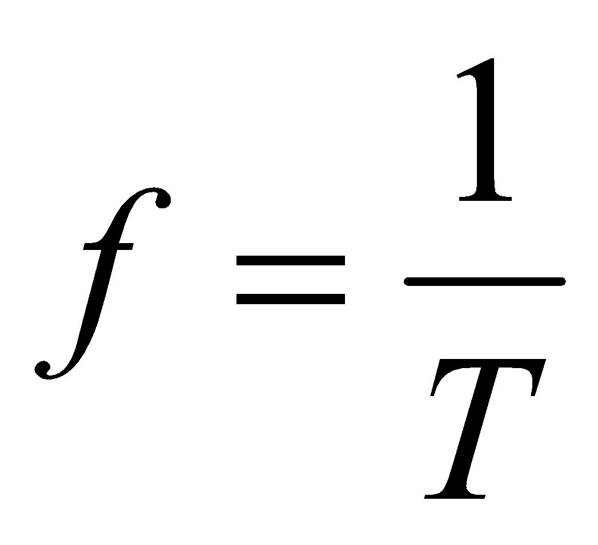, and 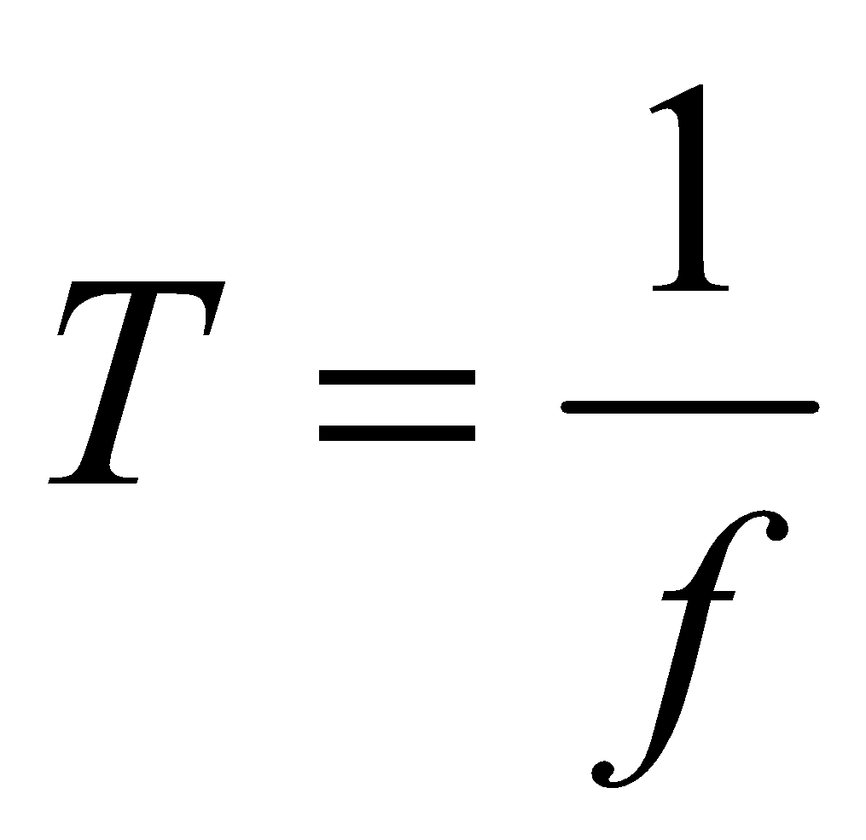.

You can calculate the speed of a wave by multiplying the wavelength by the frequency: 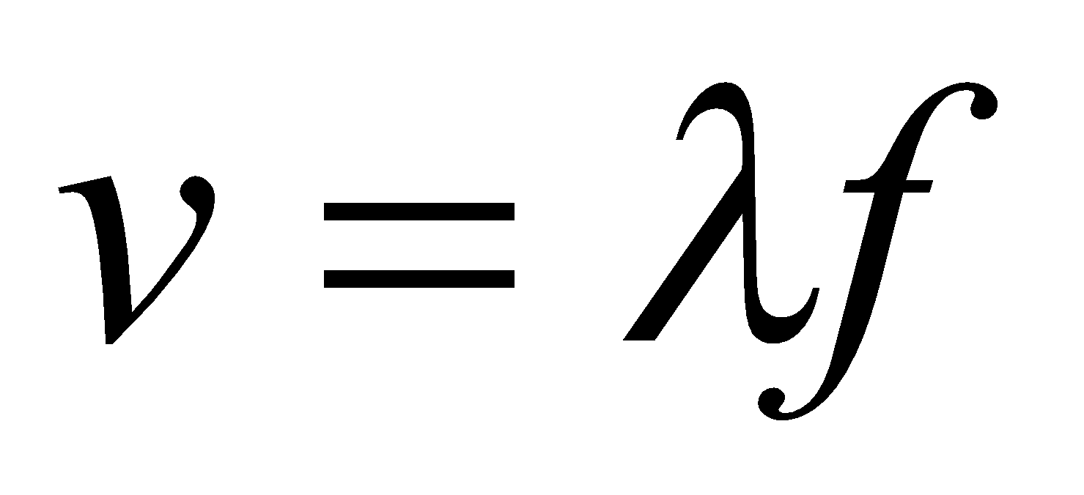.

You can calculate the speed of a wave by dividing the wavelength by the period, 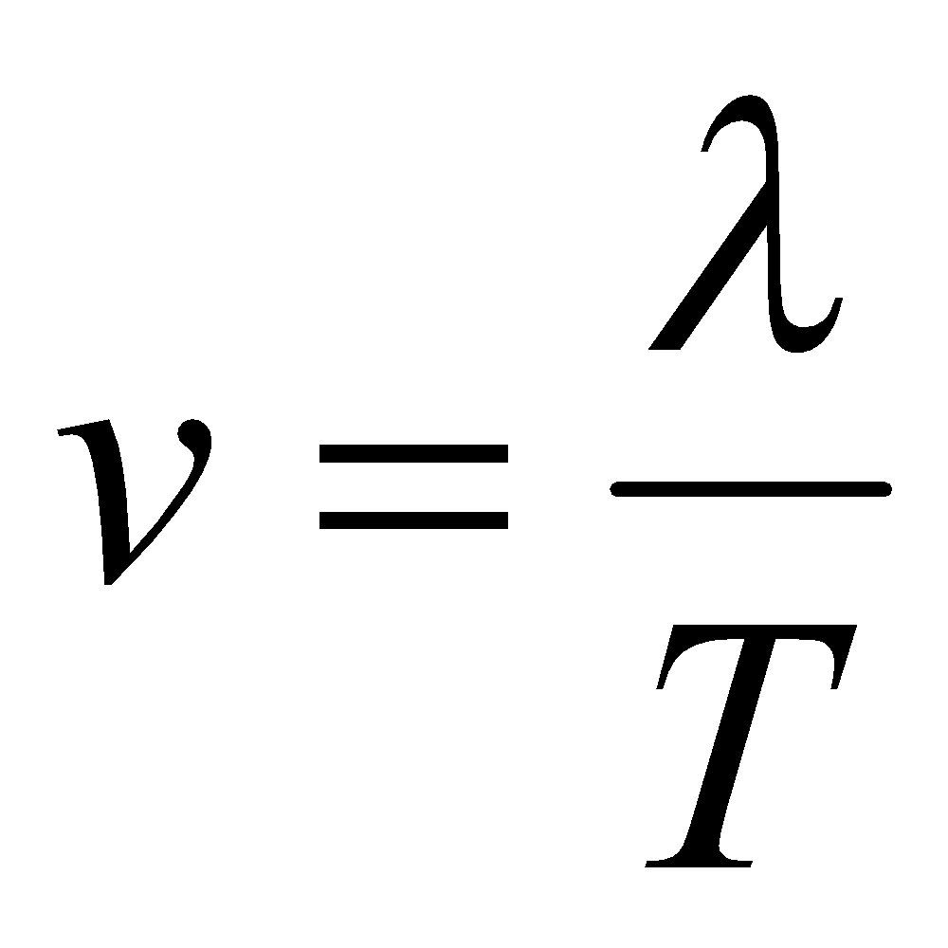.

**Transverse/longitudinal waves**

Whenever the motion of a material is at right angles to the direction in which the wave travels, the wave is a *transverse wave*.

Waves on a stringed instrument are transverse; waves in the electromagnetic spectrum, including light, are transverse.

All waves in the electromagnetic spectrum move 300 million m/s in air.

The higher the tension in a string, the faster the wave moves in that string.

When a material vibrates parallel to the direction of the wave, the wave is a *longitiudinal wave*.

Sound waves are longitudinal waves.

Light can travel through a vacuum; sound cannot.

**Interference**

*Interference* occurs when waves arrive at the same point at the same time.

In *constructive interference* the crest of one wave overlaps the crest of another. The result is a wave of increased amplitude.

In *destructive interference* the crest of one wave overlaps the trough of another. The result is a wave of reduced amplitude.

Where wave pulses overlap, the resulting displacement can be determined by adding the displacements of the two pulses. This is called superposition.

When two waves of slightly different frequency interfere, they produce beats.

The beat frequency is the difference between the frequencies of the two waves.

**Doppler Effect**

As a wave source approaches, an observer encounters waves with a higher frequency.

As a wave source moves away, an observer encounters waves with a lower frequency.

This apparent change in frequency due to motion of the source is called the Doppler effect.

The Doppler Effect is NOT related to the amplitude of a sound wave.

The frequency of the source does not change. It is only the apparent frequency that changes.

**Sound**

The pitch of a sound depends on a sound wave’s frequency.

The loudness of a sound depends on the sound wave’s amplitude.

The energy carried by a sound wave depends on the sound wave’s amplitude.

The speed of sound in air is about 340 m/s.

People can easily hear sound with frequencies of tens, hundreds, or thousands of Hz. Most musical notes have frequencies in the hundreds of Hz.

**Standing Waves**

A standing wave is a wave that appears to stay in one place

Nodes are the stationary points on a standing wave.

Antinodes are the positions on a standing waves with the largest amplitudes.

Standing waves are the result of the addition of incident and reflected waves that are confined

to a region.

The *fundamental* is the lowest frequency standing wave that can exist in a region.

On a standing wave, the wavelength is measured node-to-node-to-node.

For a standing wave with identical boundary conditions at each end:

* The fundamental frequency is *v/*2*L*
* All multiples of the fundamental can exist as harmonics.

For a standing wave with different boundary conditions at each end:

* The fundamental frequency is *v/*4*L*
* Only odd multiples of the fundamental can exist as harmonics.

**Non-rigorous definitions of voltage, current, resistance**

Voltage is provided by a battery. Voltage is measured in units of volts.

Resistance is provided by a resistor, a lamp, or any electronic device. The units of resistance are ohms (Ω).

The resistance of a resistor depends on its structure by the equation *R = ρL/A*.

Current relates to the amount of charge flowing through a resistor. The units of current are amps.

Ohm’s law states that voltage is equal to current multiplied by resistance: ***V = IR*.**

**Rigorous definitions of voltage, current, resistance**

Voltage is energy per charge.

Current is charge per time.

Power is energy per time.

Potential difference is a synonym for voltage.

**Resistors in series**

Resistors are connected in series if they are connected in a single path.

The equivalent resistance of series resistors is the sum of all of the individual resistors.

Series resistors each carry the same current, which is equal to the total current through the circuit.

The voltage across series resistors is different for each, but adds to the voltage of the battery.

The sum of voltage changes around a circuit loop is zero (Kirchoff’s loop rule).

Kirchoff’s loop rule is a statement of conservation of energy.

In Ohm’s law, use the voltage of the battery with the equivalent resistance of the circuit; or, use the voltage across a single resistor with the resistance of a single resistor.

**Resistors in parallel**

Resistors are connected in parallel if the path for current divides, then comes immediately back together.

The equivalent resistance of parallel resistors is less than any individual resistor. Mathematically, for parallel resistors, 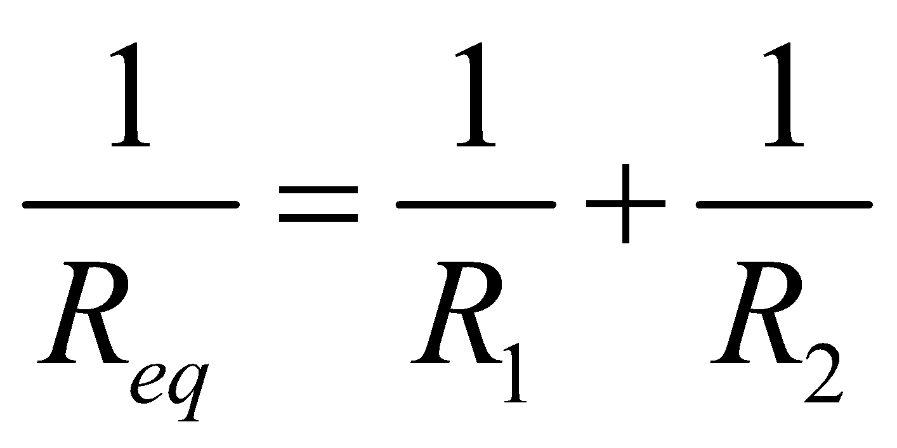.

The voltage across parallel resistors is the same for each, and equal to the total voltage.

Parallel resistors each carry different currents, which add to the total current in the circuit.

Current entering a junction is equal to current leaving a junction (Kirchoff’s junction rule).

Kirchoff’s junction rule is a statement of conservation of charge.

**Ammeters and Voltmeters**

An ammeter measures current through a resistor. It is connected in series with a resistor.

A voltmeter measures voltage across a resistor. It is connected in parallel with a resistor.

**Power and Brightness**

The power dissipated by a resistor is equal to the resistor’s voltage squared divided by its resistance: 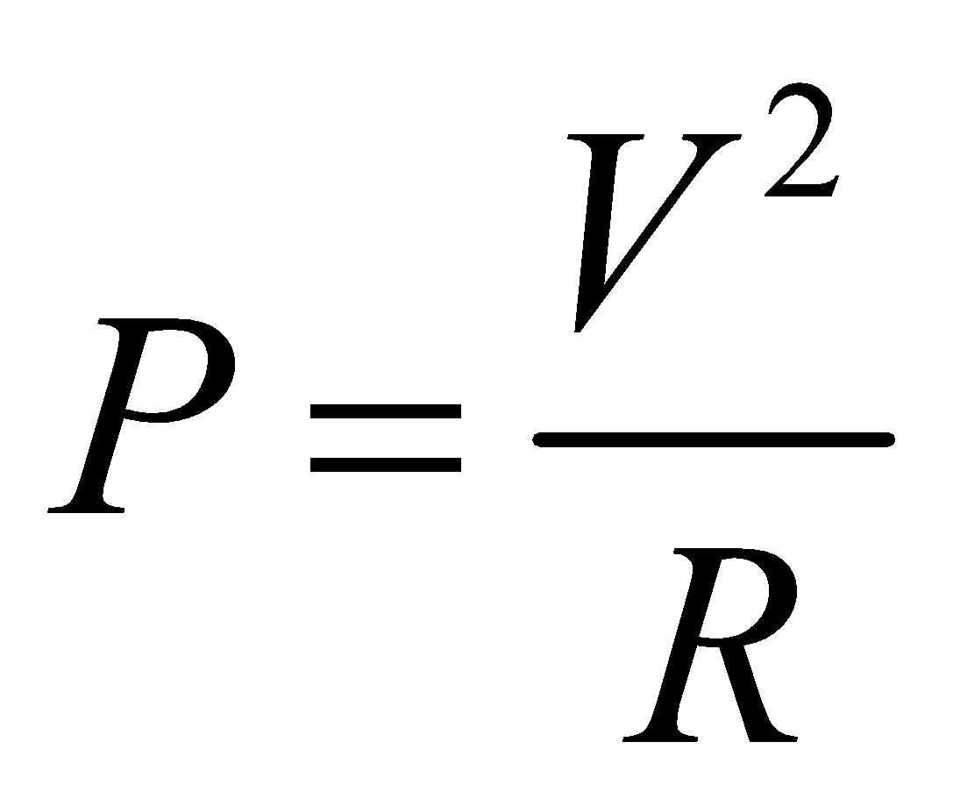

Power is measured in units of watts.

The brightness of a light bulb depends on the power dissipated by the bulb.

**Batteries**

A real battery consists of two elements in series: an EMF, and an internal resistance.

**EMF** is the voltage provided internally by a battery.

**Internal resistance** of a battery is inherently part of the battery’s structure.

The **terminal voltage** of a battery is what a voltmeter placed across the battery’s terminals would measure. Terminal voltage is less than the battery’s EMF.

**Charge**

Charge is measured in units of coulombs.

Charge is conserved – it can neither be created nor destroyed, though positive charge can neutralize negative charge.

The smallest possible unit of charge is *e* = 1.6 x 10-19 C. Experimental results showing a charge that’s not a multiple of *e* should be rejected.

Most charged objects in a laboratory have microcoulombs or nanocoulombs worth of charge.

The electric force between two isolated charged objects is given by the equation 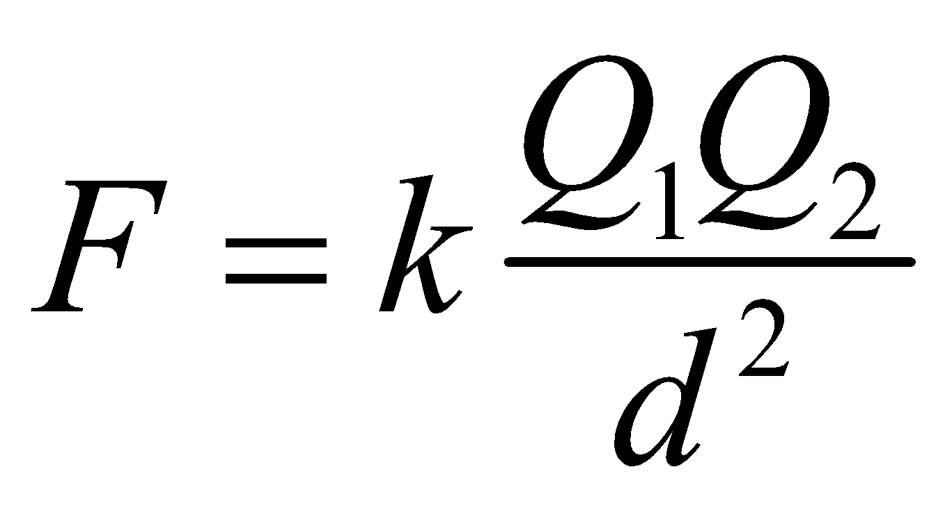, where:

* *Q* is the amount of charge on each object
* *d* is the distance between the objects’ centers
* *k* is the coulomb’s law constant, 9.0 x 109 N∙m2/C2

**Resistivity**

Resistivity *ρ* is a property of a material, measured in units of Ω∙m.

The resistance *R* of a length of wire *L* is given by 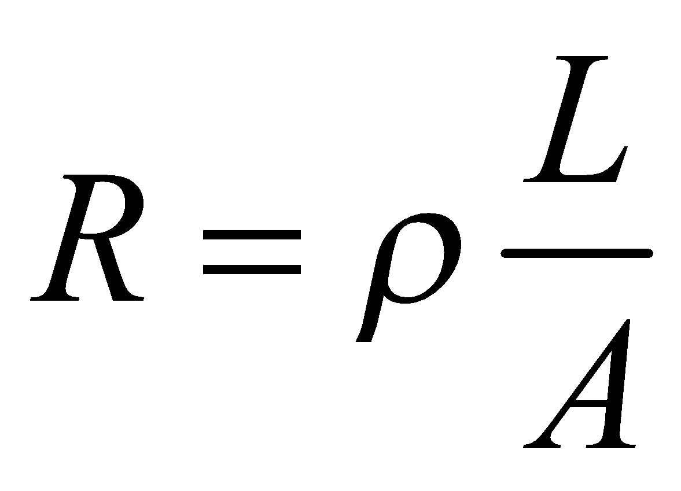, where *A* is the cross-sectional area of the wire.

**Definition of Equilibrium**

An object is in equilibrium if it is moving in a straight line at constant speed. This includes an object remaining at rest.

The net force on an object in equilibrium is zero.

**Force and Net Force**

A force is a push or a pull that acts on an object.

Force is measured with a spring scale or a platform scale.

The units of force are newtons.

Forces acting in the same direction add together to determine the net force.

Forces acting in opposite directions subtract to determine the net force.

The net force is always in the direction of acceleration.

**Solving equilibrium problems**

The three-step problem solving process:

1. Draw a free-body diagram.
2. If any force acts at an angle, break it into components.
3. Set up two equations:

* (up forces) – (down forces) = 0
* (left forces) – (right forces) = 0.

A free-body diagram includes:

1. A labeled arrow representing each force. Each arrow begins on the object and points in the direction in which the force acts.
2. A list of the forces, indicating the object applying the force and the object experiencing the force.

**Mass and Weight**

Mass tells how much material is contained in an object.

The units of mass are kilograms.

Weight is the force of a planet acting on an object.

On earth’s surface, the gravitational field is 10 N/kg. This means that on earth, 1 kg of mass weighs 10 N.

**Normal force**

A normal force is the force of a surface on an object in contact with that surface.

A normal force acts perpendicular to a surface.

A platform scale reads the normal force.

**Adding perpendicular forces**

When two concurrent forces act perpendicular to one another, the resultant force is

* Greater than if the forces acted in opposite directions
* Less than if the forces acted in the same direction
* At an angle, but closer to the larger force

To determine the resultant force, draw the forces to scale. Create a rectangle, then measure the diagonal of the rectangle and its angle.

The “magnitude” of a force means the amount of the resultant force.

***x-* and *y-*components**

Any diagonal force can be written in terms of two perpendicular force components, called the *x*- and *y*- components.

To determine the amount of each component, draw the diagonal force to scale. Draw dotted lines from the tip of the force arrow directly to the *x*- and *y*- axes. Measure each component.

When the angle *θ* of the diagonal force is measured from the horizontal,

* The horizontal component of the force is the magnitude of the force times cos *θ*
* The vertical component of the force is the magnitude of the force times sin *θ*

**Solving problems with forces**

The three-step problem solving process:

1. Draw a free-body diagram.
2. Determine the net force in each direction, even if that net force is an expression with unknown variables in it.
3. Write two equations:

* *F*net = *ma* in the vertical direction
* *F*net = *ma* in the horizontal direction

**A free-body diagram includes:**

1. A labeled arrow representing each force. Each arrow begins on the object and points in the direction in which the force acts.
2. A list of the forces, indicating the object applying the force and the object experiencing the force.

**Friction force**

The force of friction is the force of a surface on an object acting along the surface.

The force of friction acts in the opposite direction of an object’s motion.

The coefficient of friction *μ* is not a force.

The coefficient of friction is a number that tells how sticky two surfaces are

The force of friction is equal to the coefficient of friction times the normal force ***F*f = *μF*n**

The following table is for reference, and not to be memorized; other coefficients of friction can be looked up.



The coefficient of kinetic friction is used when an object is moving; the coefficient of static friction is used when an object is not moving. Both types of coefficients of friction obey the same equation.

The coefficient of static friction can take on any value up to a maximum, which depends on the properties of the materials in contact.

For two specific surfaces in contact, the maximum coefficient of static friction is greater than the coefficient of kinetic friction.

**Gravitation**

All massive objects attract each other with a gravitational force.

The **gravitational force** *F*G of one object on another is given by 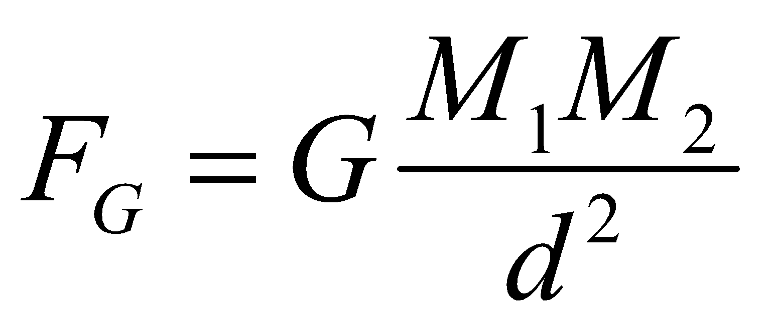:

* *M* is the mass of an object
* *d* is the distance between the centers of the two objects
* *G* is the universal gravitation constant, 6.7 x 10-11 N•m2/kg2

The **gravitational field** *g* near an object of mass *M* is given by 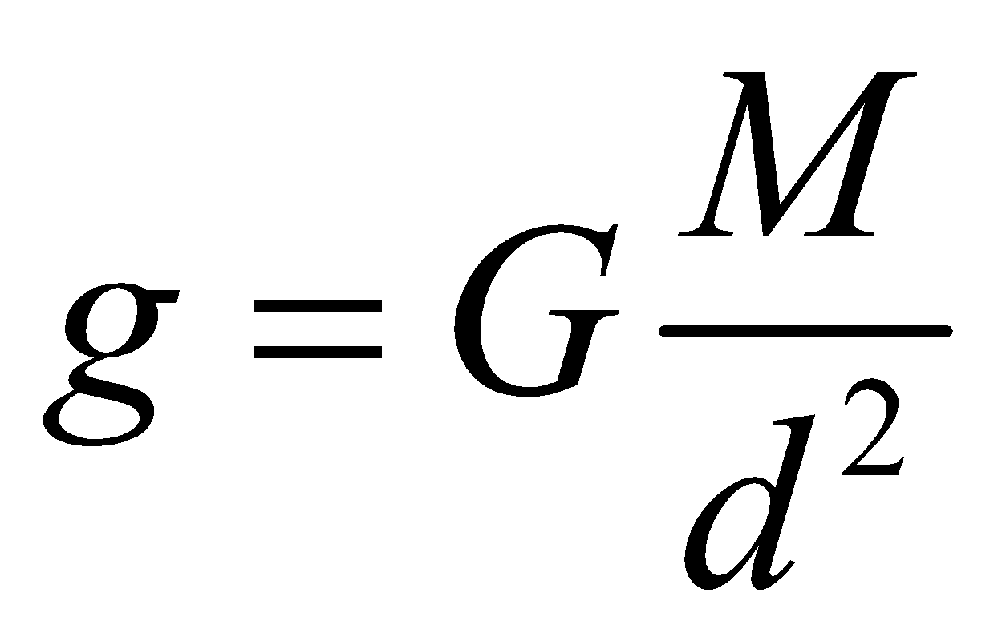, where *d* represents the distance from the object’s center to anywhere you’re considering.

The **weight** of an object near a planet is given by *mg*, where *g* is the gravitational field due to the planet at the object’s location.

The gravitational field near a planet is always equal to the free-fall acceleration.

**Gravitational mass** is measured by measuring an object’s weight using *weight = mg*

**Inertial mass**is measured by measuring the net force on an object, measuring the object’s acceleration, and using *F*net = *ma*.

In all experiments ever performed, gravitational mass is equal to inertial mass.

**Inclined Planes**

When an object is on an inclined plane, break the object’s weight into components parallel to and perpendicular to the incline. Do not use *x* and *y* axes.

* The component of the object’s weight parallel to the incline is *mg*sin*θ*
* The component of the object’s weight perpendicular to the incline is *mg*cos*θ*

**Newton’s Third Law**

Newton’s Third Law says that the force *of* object A *on* object B is **equal** to the force *of* object B *on* object A.

A “Third Law Force Pair” is a pair of forces that obeys Newton’s third law.

Two forces in a third law force pair can never act on the same object.

**Circular motion**

An object moving at constant speed *v* in a circle of radius *r* has an acceleration of magnitude *v*2/*r*, directed toward the center of the circle.

**Definition of Work**

The amount of work done by a steady force is the amount of force multiplied by the distance an object moves parallel to that force: ***W = F*∙Δ*x*║**

*Positive* work is done by a force parallel to an object’s displacement.

*Negative* work is done by a force antiparallel to an object’s displacement.

Work is a scalar quantity – it can be positive or negative, but does not have a direction.

The area under a force vs. displacement graph is work.

**Equations for different forms of energy**

All forms of energy have units of joules, abbreviated J.

* **Kinetic energy**: *KE =* ½*mv*2. Here, *m* is the mass of the object, and *v* is its speed.
* **Gravitational potential energy**: *PE* = *mgh*. Here, *m* is the mass of the object, *g* is the gravitational field, and *h* is the vertical height of the object above its lowest position.
* The term ***mechanical energy*** refers to the sum of a system’s kinetic and potential energy.
* **Spring potential energy**: *PE* = ½*kx*2. Here, *k* is the spring constant, and *x* is the distance the spring is stretched or compressed from its equilibrium position. (See the section below about springs)
* **Rotational kinetic energy (a form of internal energy):** *KEr =* ½*Iω*2. Here, *I* is the rotational inertia of the object, and *ω* is the angular speed of the object.

**Work-energy theorem**

Before starting a work-energy problem, define the object or system being described.

The work-energy theorem states that the net work done by external forces changes the system’s mechanical energy:

*W*ext = (*KE*f – *KE*i) + (*PE*f – *PE*i)

**Force of a spring:**

A spring pulls with more force the farther the string is stretched or compressed.

The force of a spring is given by the equation *F = kx*. Here, *k* is the spring constant of the spring, and *x* is the distance the spring is stretched or compressed.

The spring constant is a property of a spring, and is always the same for the same spring.

The standard units of the spring constant are N/m.

**Vertical springs:**

When dealing with an object hanging vertically from a spring, it’s easiest to consider the spring-earth-object system.

The potential energy of the spring-earth-object system is *PE =* ½*kx*2, where *x* is measured from the position where the object would hang in equilibrium.

**Power**

Power is defined as the amount of work done in one second, or energy used in one second:

*power = work / time*

The units of power are joules per second, which are also written as watts.

An alternate way of calculating power when a constant force acts is *power = force ∙ velocity*

**Rotational Inertia table – no need to memorize**

